CREATE TABLE employees1 (

employee_id NUMBER PRIMARY KEY,

first_name VARCHAR2(50),

last_name VARCHAR2(50),

salary NUMBER,

department_id NUMBER

);

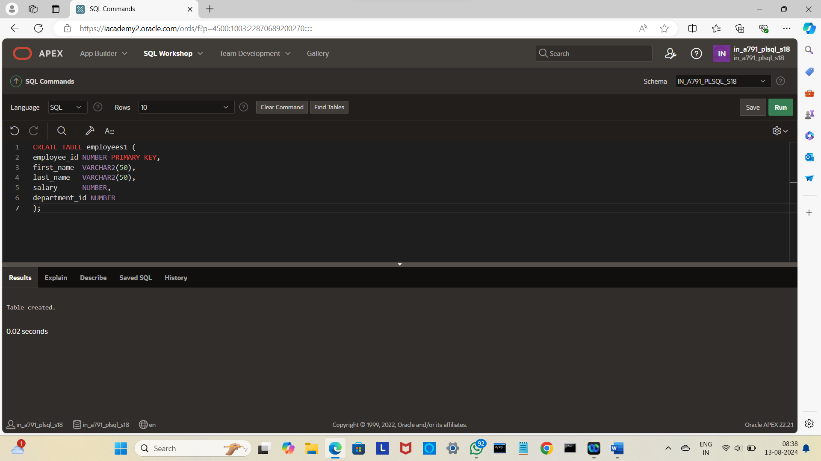

INSERT INTO employees1 VALUES (101, 'John', 'Doe',50000,10);

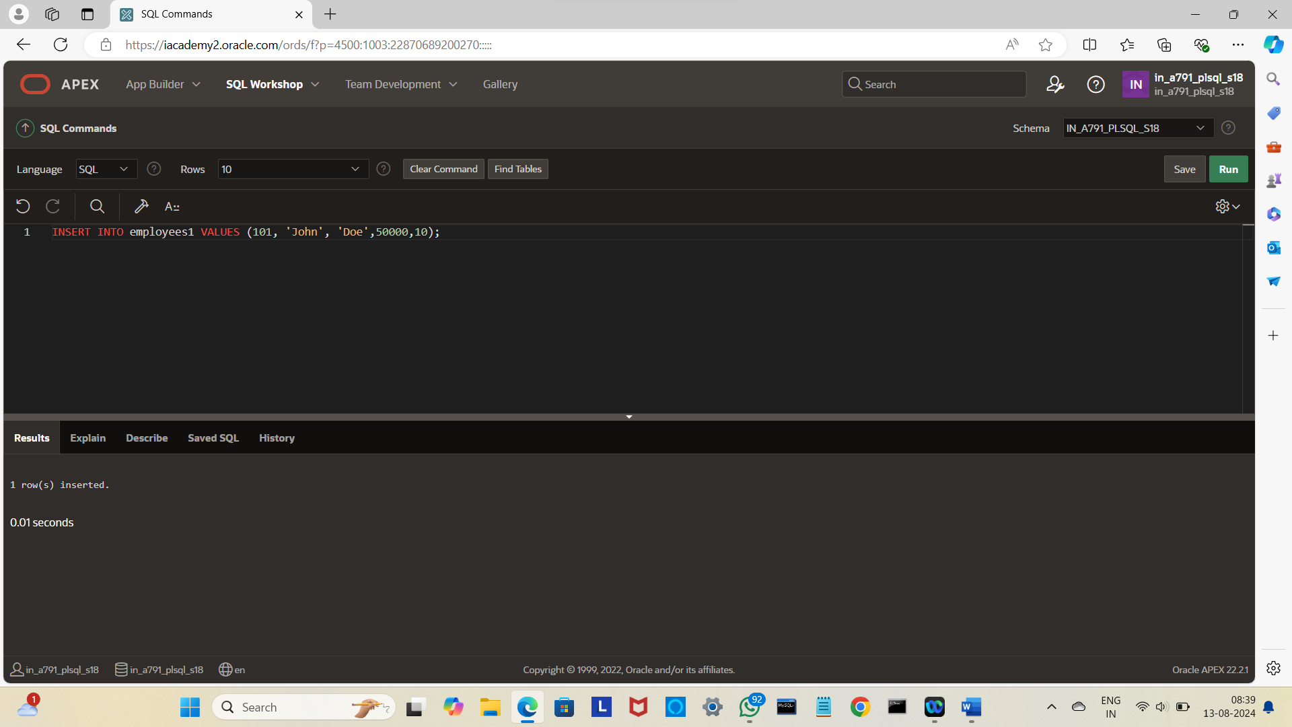

INSERT INTO employees1 VALUES (103, 'Robert', 'Brown',55000,10);

INSERT INTO employees1 VALUES (102, 'Jane', 'Smith',60000,20);

INSERT INTO employees1 VALUES(104,'Emily','Davis',70000,30);

select*from employees;

CREATE OR REPLACE PACKAGE employee_pkg IS

TYPE employee_rec IS RECORD (

employee_id NUMBER,

first_name VARCHAR2(50),

last_name VARCHAR2(50),

salary NUMBER

);

TYPE employee_tbl IS TABLE OF employee_rec;

FUNCTION get_employee(emp_id IN NUMBER) RETURN employee_rec;

FUNCTION get_employees_by_dept(dept_id IN NUMBER) RETURN employee_tbl;

PROCEDURE update_employee_salary(emp_id IN NUMBER, new_salary IN NUMBER);

END employee_pkg;

/

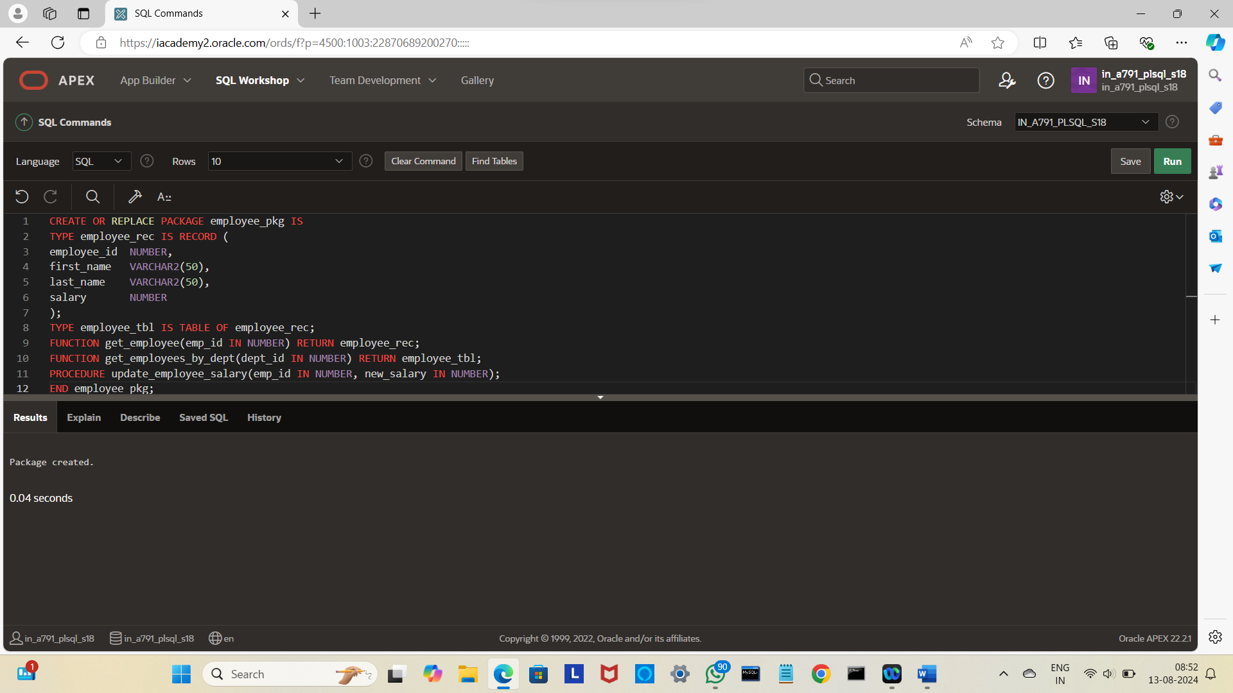

CREATE OR REPLACE PACKAGE BODY employee_pkg IS

FUNCTION get_employee(emp_id IN NUMBER) RETURN employee_rec IS

emp employee_rec;

BEGIN

SELECT employee_id, first_name, last_name, salary

INTO emp

FROM employees1

WHERE employee_id = emp_id;

RETURN emp;

END get_employee;

FUNCTION get_employees_by_dept(dept_id IN NUMBER) RETURN employee_tbl IS

emp_table employee_tbl;

BEGIN

SELECT employee_id, first_name, last_name, salary

BULK COLLECT INTO emp_table

FROM employees1

WHERE department_id = dept_id;

RETURN emp_table;

END get_employees_by_dept;

PROCEDURE update_employee_salary(emp_id IN NUMBER, new_salary IN NUMBER) IS

BEGIN

UPDATE employees1

SET salary = new_salary

WHERE employee_id = emp_id;

COMMIT;

END update_employee_salary;

END employee_pkg;

/

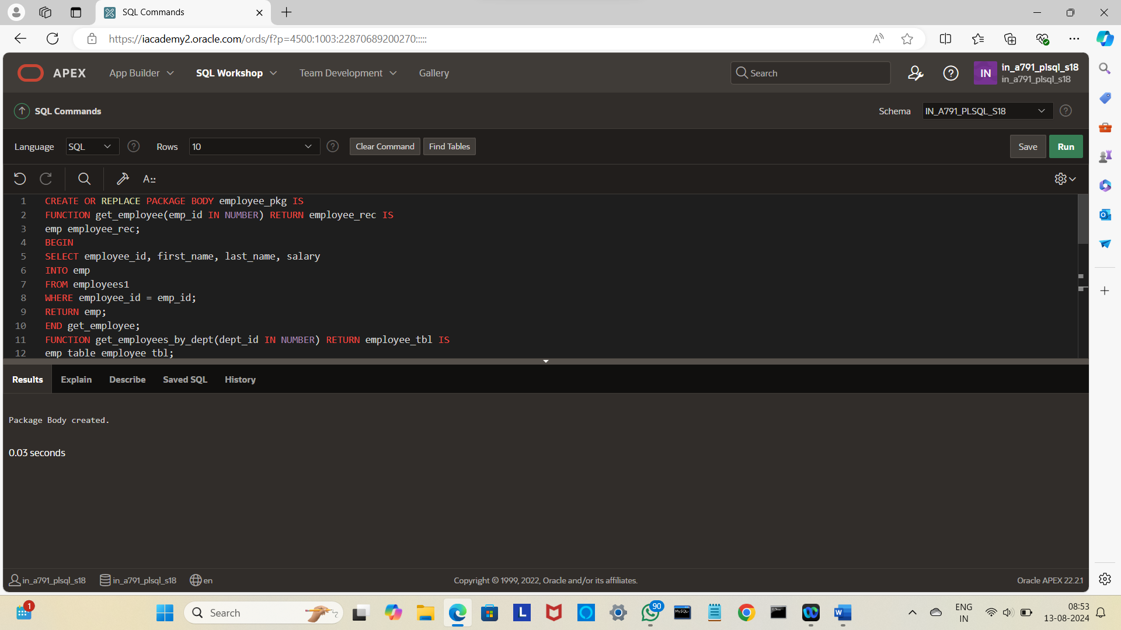

DECLARE

emp_rec employee_pkg.employee_rec;

BEGIN

emp_rec := employee_pkg.get_employee(103);

DBMS_OUTPUT.PUT_LINE('Employee: ' || emp_rec.first_name || ' ' || emp_rec.last_name || ', Salary: ' || emp_rec.salary);

END;

/

